**Deciphering/Decryption**

The process of converting from cipher text to plain text is called deciphering.

The following example will explain the procedure for deciphering.

Example 6. Decipher the Cipher text = MOFZ for Key matrix = $\left[\begin{matrix}3 & 3 \\ 2 & 5\end{matrix}\right]$.

Solution: Recall the formula which we used for enciphering

C = KP (mod 26)

Formula for deciphering

P = $K^{-1}C$ (mod 26)

$K^{-1}= \frac{Adj(K)}{det⁡(K)}$ (mod 26)

Thus each plain text vector can be recovered from ciphertext vector by multiplying it on the left by $K^{-1}$ (mod 26).

Step 1 First find $K^{-1}$, so

det(K) = $\left|K\right|=\left|\begin{matrix}3 & 3 \\ 2 & 5\end{matrix}\right|=15-6=9$

$K^{-1}= \frac{\left[\begin{matrix}5 & -3 \\ -2 & 3\end{matrix}\right]}{9}=9^{-1}\left[\begin{matrix}5 & -3 \\ -2 & 3\end{matrix}\right]$

What is the inverse of 9 modulo 26? Let it be x, then 9x = 1(mod 26)

9.1 = 9 ≠ 1(mod26)

9.2 = 18 ≠ 1(mod26)

9.3 = 27 = 1(mod26)

Hence, $9^{-1}=3 (mod 26)$

Therefore,

$K^{-1}=9^{-1}\left[\begin{matrix}5 & -3 \\ -2 & 3\end{matrix}\right]=3\left[\begin{matrix}5 & -3 \\ -2 & 3\end{matrix}\right]=\left[\begin{matrix}15 & -9 \\ -6 & 9\end{matrix}\right]=\left[\begin{matrix}15 & 17 \\ 20 & 9\end{matrix}\right](mod26)$

Step 2 Now, we will decipher MO first, then we will decipher FZ. For this we take

C = $\left[\begin{matrix}M \\ O\end{matrix}\right]$ = $\left[\begin{matrix}13 \\ 15\end{matrix}\right]$

P = $K^{-1}C$ (mod 26) = $\left[\begin{matrix}15 & 17 \\ 20 & 9\end{matrix}\right]\left[\begin{matrix}13 \\ 15\end{matrix}\right]=\left[\begin{matrix}450 \\ 395\end{matrix}\right]$ (mod 26) = $\left[\begin{matrix}8 \\ 5\end{matrix}\right]$

Alphabets equivalent of the vector is $\left[\begin{matrix}H \\ E\end{matrix}\right]$

For FZ, C = $\left[\begin{matrix}F \\ Z\end{matrix}\right]$ = $\left[\begin{matrix}6 \\ 0\end{matrix}\right]$

and P = $K^{-1}C$ (mod 26)= $\left[\begin{matrix}15 & 17 \\ 20 & 9\end{matrix}\right]\left[\begin{matrix}6 \\ 0\end{matrix}\right]=\left[\begin{matrix}90 \\ 120\end{matrix}\right]\left(mod 26\right)=\left[\begin{matrix}12 \\ 16\end{matrix}\right]$

Alphabets equivalent of the vector is $\left[\begin{matrix}L \\ P\end{matrix}\right]$

So all plain text is HELP.

Example 7. Decode the following Hill 2-cipher, which was enciphered by the matrix $K=\left[\begin{matrix}5 & 6 \\ 2 & 3\end{matrix}\right]$

GTNKGKDUSK

Solution: We first find the inverse of K (mod 26) as

$$K^{-1}=3^{-1}\left[\begin{matrix}3 & -6 \\ -2 & 5\end{matrix}\right]=9\left[\begin{matrix}3 & -6 \\ -2 & 5\end{matrix}\right]$$

$$=\left[\begin{matrix}27 & -54 \\ -18 & 45\end{matrix}\right]\left(mod26\right)=\left[\begin{matrix}1 & 24 \\ 8 & 19\end{matrix}\right]$$

Next we write numerical equivalent of cipher text, which is

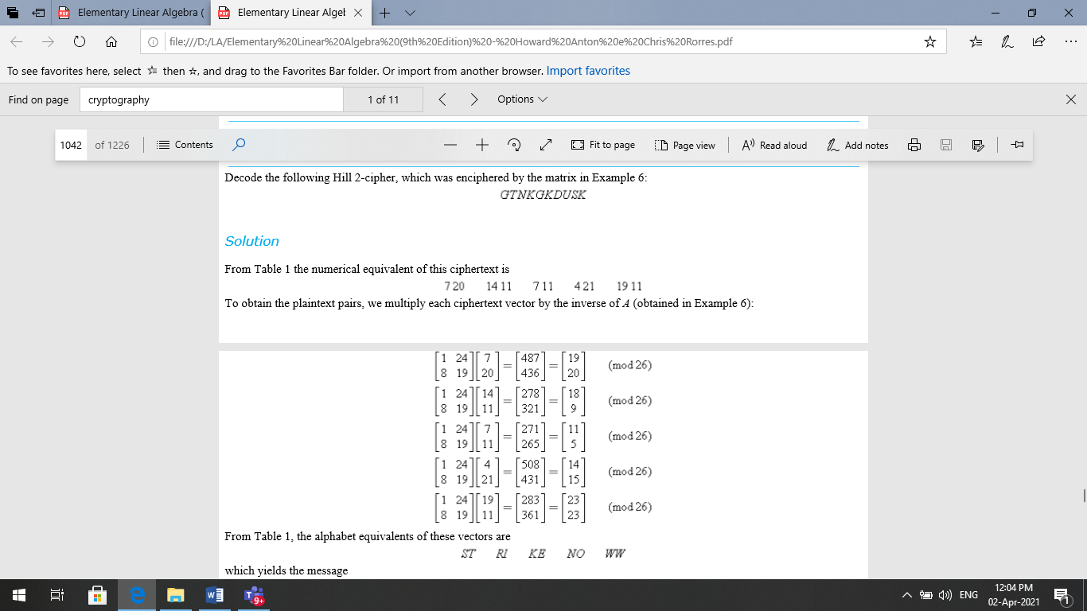



Which yields the message STRIKE NOW

**Example 8** Decode the Hill 3-cipher **XCVAFA** which was enciphered by the matrix key

$K=\left[\begin{matrix}1 & 2 & 0 \\ 0 & 1 & 2 \\ 0 & 1 & 1\end{matrix}\right]$

**Solution:**

First we have to calculate the inverse of K

$\left[\begin{matrix}1 & 2 & 0 \begin{matrix}1 & 0 & 0\end{matrix} \\ 0 & 1 & 2 \begin{matrix}0 & 1 & 0\end{matrix} \\ 0 & 1 & 1 \begin{matrix}0 & 0 & 1\end{matrix}\end{matrix}\right]$

**.**

**.**

**.**

Work to do

Question 1. Determine whether the matrix is invertible modulo 26. If so, find its inverse modulo 26 and check your work by

$$AA^{-1}=A^{-1}A=I(mod 26)$$

a) A= $\left[\begin{matrix}9 & 1 \\ 7 & 2\end{matrix}\right]$ b) B = $\left[\begin{matrix}1 & 8 \\ 1 & 3\end{matrix}\right]$ c) A= $\left[\begin{matrix}2 & 1 \\ 1 & 7\end{matrix}\right]$

Question 2.

Decode the following Hill 2-cipher which was enciphered by the matrix $\left[\begin{matrix}4 & 1 \\ 3 & 2\end{matrix}\right]$

SAKNOXAOJX

Question 3.

Decode the Hill 3-cipher **LQVGKE** which was enciphered by the matrix key

$K=\left[\begin{matrix}1 & 2 & 4 \\ 0 & -1 & 2 \\ 0 & 1 & -1\end{matrix}\right]$

**Important Note:**

